Exception Handling in Python

What is Exception Handling?
Exception handling in Python allows you to deal with runtime errors (exceptions) to prevent program crashes and ensure smooth execution.

Common Built-in Exceptions
Some common exceptions in Python include:
- ZeroDivisionError: Division by zero
- TypeError: Invalid operation between different data types
- ValueError: Inappropriate value
- IndexError: Accessing an invalid index in a list or tuple
- KeyError: Accessing a non-existent key in a dictionary
- FileNotFoundError: File does not exist
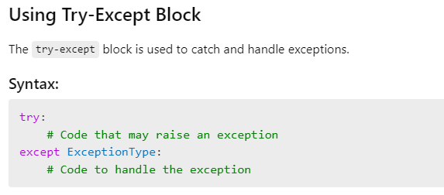
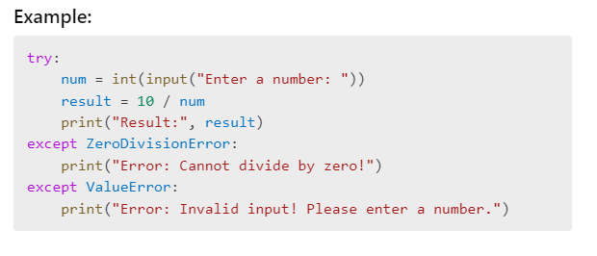
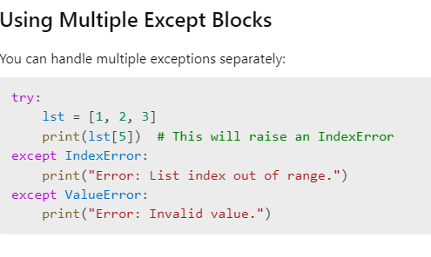
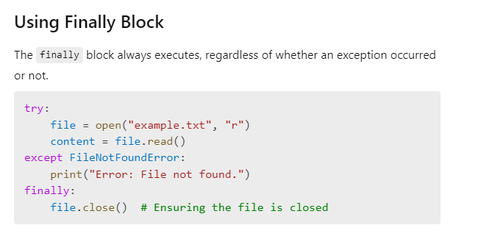
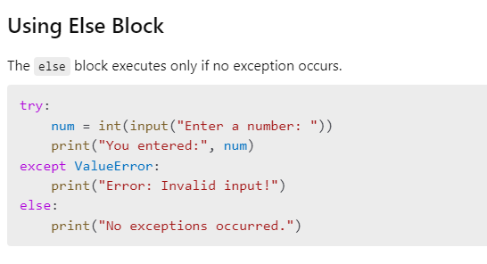
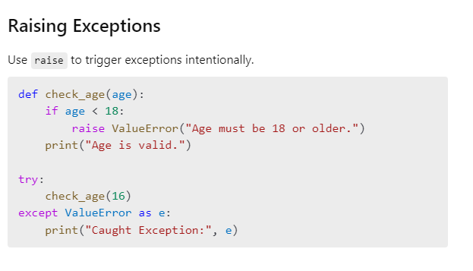
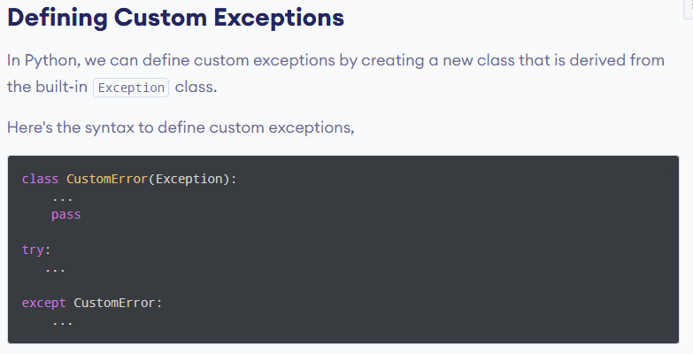
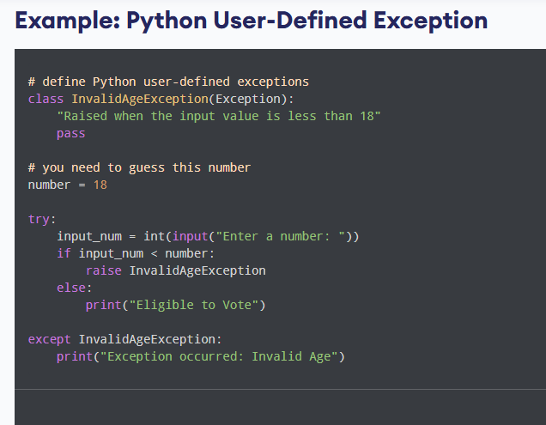
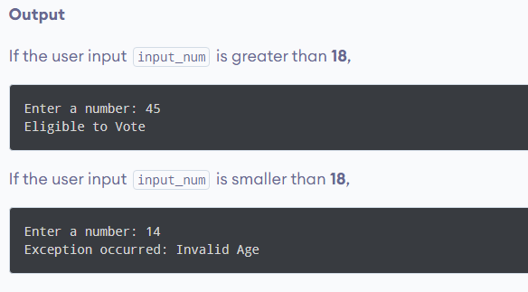

NOTE: (Not in syllabus)

Python Built-in Exceptions
Illegal operations can raise exceptions. There are plenty of built-in exceptions in Python that are raised when corresponding errors occur.
We can view all the built-in exceptions using the built-in local() function as follows:

